INTRODUCTION TO ICT
MUHAMMAD MUJTABA
LAB INSTRUCTOR: MAM HUFSA MOHSIN

Abstract
ICT LAB ACTIVITIES.
Activity#1:
Consider this sentence: “Computers are everywhere.” Does it sound like an overstatement or a cliche’? No matter how you perceive the impact of computers, the statement is true. Computers are everywhere. In fact, you can find them in some pretty unlikely places, including your family car, your home appliances, and even your alarm clock!

Activity#2:
Consider this sentence: “Computers are everywhere.” Does it sound like an overstatement or a cliche’? No matter how you perceive the impact of computers, the statement is true. Computers are everywhere. In fact, you can find them in some pretty unlikely places, including your family car, your home appliances, and even your alarm clock!

Activity#3:
CONSIDER this sentence: “COMPUTERS ARE EVERYWHERE.” Does it sound like an overstatement or a cliche’? No matter how you perceive the impact of computers, the statement is true. Computers ARE everywhere. In fact, you can find them in some pretty unlikely places, including your family car, your home appliances, and even your alarm clock!

Activity#4:
C_{ONSIDER} this sentence: “COMPUTERS ARE EVERYWHERE.” Does it sound like an overstatement or a cliche’? No matter how you perceive the impact of computers, the statement is true. Computers A^{RE} everywhere. In fact, you can find them in some pretty unlikely places, including your family car, your home appliances, and even your alarm clock!

Activity#5:
Consider this sentence: “Computers are everywhere.” Does it sound like
- an overstatement
- or a cliche’?
No matter how you perceive the impact of computers, the statement is true. Computers are everywhere. In fact, you can find them in some pretty unlikely places, including
- your family car,
- your home appliances,
- and even your alarm clock!

Activity#6:
1. Main-Item # 1
1.1. Sub-Item# 1.1
1.1.1. sub-sub-item # 1.1.1
1.2. sub-item # 1. 2
2. Main-item # 2
3. Main-item # 3

Activity#7:

Activity#8:
Table 1

Introduction | To | Information | And | Communication
Technology

Activity#9:

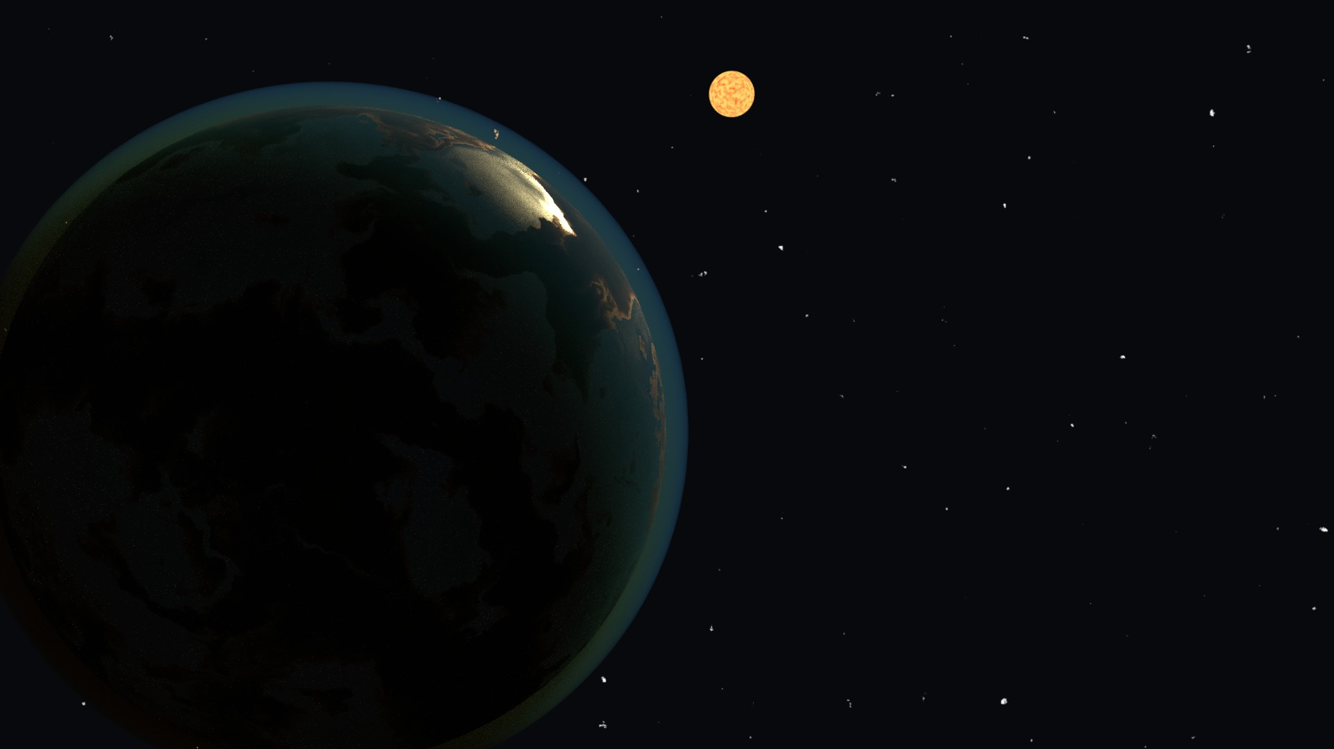

Activity#10:
Hello

Activity# 11:

Activity #12:

